HCL AppScan On Cloud

Grafana Dashboard Application Onboarding

Prepared By:

Ramesh Babu,   
HCL AppScan Senior Technical Specialist /  
 Technical Advisor

Document Version : v1.1

Date : 25th October 2023

Table of Contents

1. Version history: 2

1 Setup 3

1.1 Hardware requirements – Grafana, MySQL 3

2 Install MySQL and Create Database 3

3 Grafana installation on Windows 5

3.1 **Install with Windows installer (recommended)** 6

4 Setting up the link to the Database 12

5 Install the Node JS runtime of version 16.16.0 14

5.1 Configure the .env file 15

6 Setup the Dashboard 18

7 Grafana dashboards – Graphs 23

8 Testing 23

# Version history:

|  |  |  |  |
| --- | --- | --- | --- |
| **Version number** | **Purpose/change** | **Author** | **Date** |
| Draft | Initial Setup of document | Ramesh babu | 25/10/23 |
| 1.1 | * Added bullets for steps and center aligned the screenshots and its description * Added Version info for MySQL and Grafana | Ramesh babu | 27/11/23 |
| 1.2 | * Hardware specification was updated | Ramesh babu | 28/11/23 |
| 1.3 | * Added border to all the images | Ramesh babu | 28/11/23 |
|  |  |  |  |
|  |  |  |  |
|  |  |  |  |
|  |  |  |  |
|  |  |  |  |
|  |  |  |  |
|  |  |  |  |

# Setup

## Hardware requirements – Grafana, MySQL

## Grafana setup was tested on ‘Microsoft Windows Server 2016 Datacenter – 64-bit OS’.

* Hardware specifications mentioned under’ MySQL installer’, ‘Grafana installer’ links can be used to setup hardware. (not tested)

# Install MySQL and Create Database

# Install MySQL using the below link:

<https://dev.mysql.com/downloads/workbench/>

* Open MySQL Workbench, Create a database for Grafana

* Database is created.

# Grafana installation on Windows

You can either download the Windows installer package or a standalone Windows binary file.

1. Navigate to [Download Grafana | Grafana Labs](https://grafana.com/grafana/download?pg=graf&plcmt=deploy-box-1)
2. Select a Grafana version you want to install. (Recommended version: 9.3.2)
   * The most recent Grafana version is selected by default.
   * The **Version** field displays only finished releases. If you want to install a beta version, click **Nightly Builds** and then select a version.
3. Select an **Edition**. (in this case OSS)
   * **Enterprise** - Recommended download. Functionally identical to the open-source version, but includes features you can unlock with a license if you so choose.
   * **Open Source** - Functionally identical to the enterprise version, but you will need to download the enterprise version if you want enterprise features.
4. Click **Windows**.

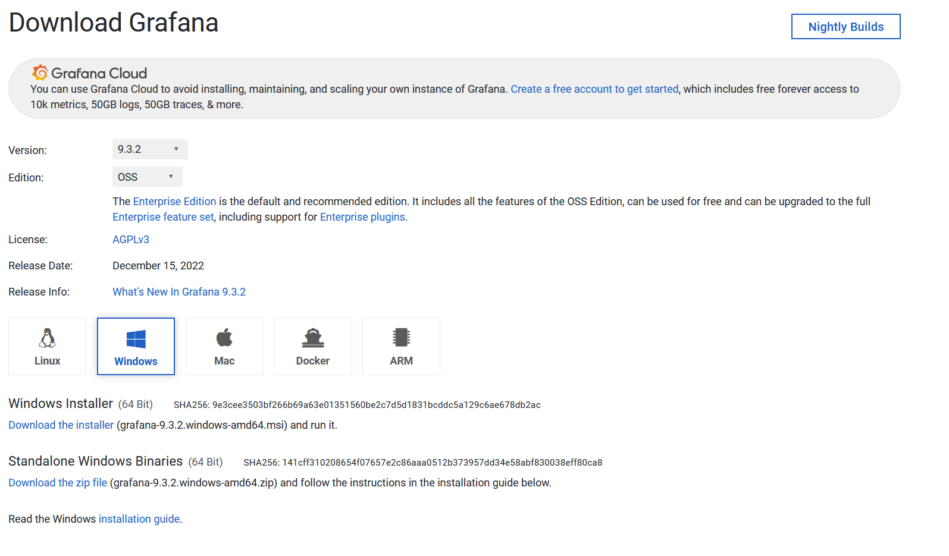

You can either use the Windows installer or you can install a standalone Windows binary.

## **Install with Windows installer (recommended)**

* Click **Download the installer**.
* Open and run the installer (Run as administrator).
* After downloading the installer, go ahead and install the .exe  
  You will see the following screen appear.  
    
  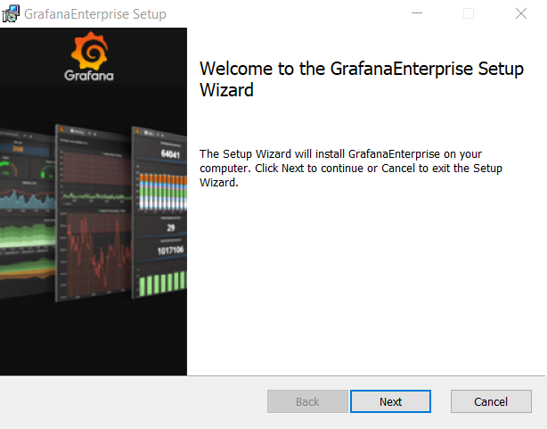

Go ahead and click next and accept the license agreement and click next.  
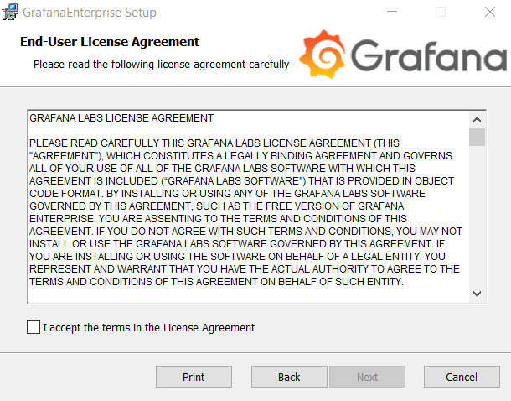  
In the next screen you will be presented with the following options.  
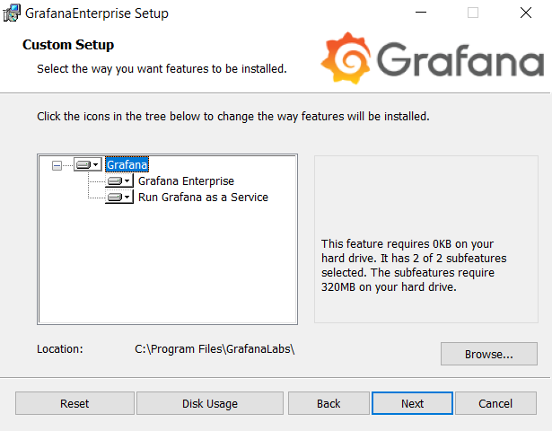

* What to install and where to install it to. Select the options that fits your environment and click next.

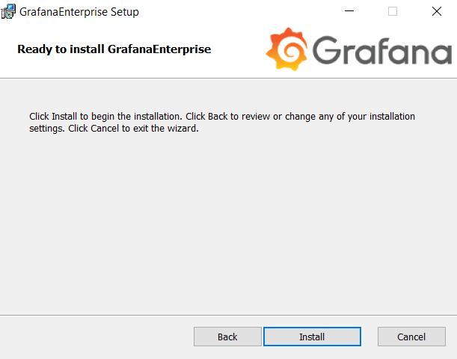

* In this last screen click install.  
    
  Wait until the installation finishes. Then click finish  
  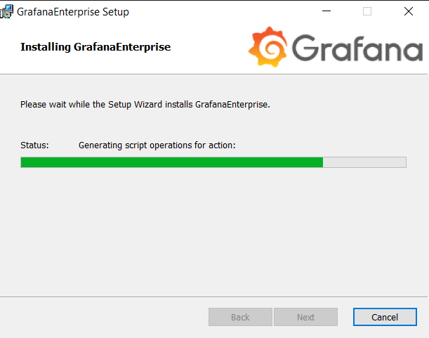  
  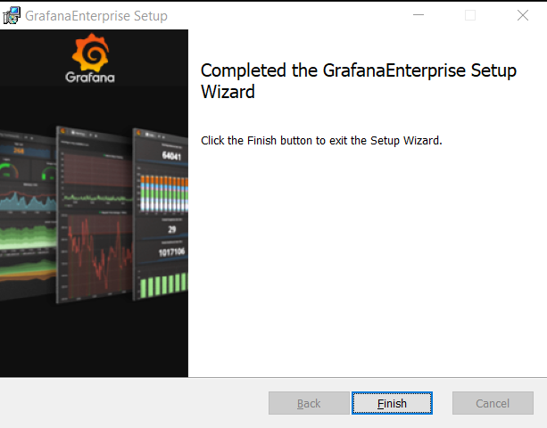
* To run Grafana now, open your browser and go to the Grafana port (http://localhost:3000/ is default) and use the following credentials to login for the first time.  
  Username: admin  
  Password: admin
* After entering these credentials, you get the following screen.  
  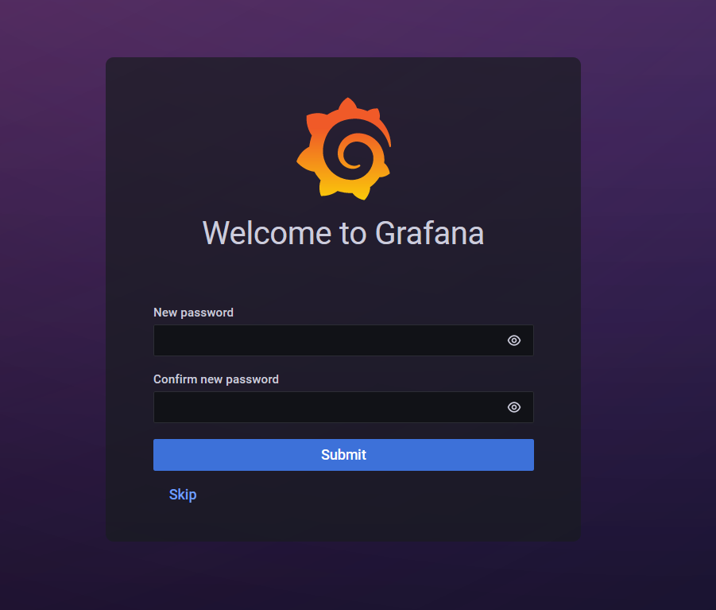
* Now enter a new password for the admin user.

Now the installation is complete, and when you login with your new credentials you will get into the main screen of Grafana.

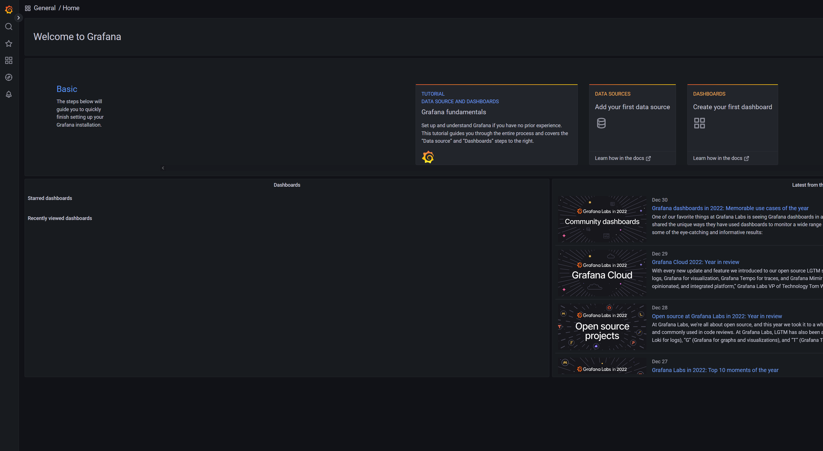

# Setting up the link to the Database

Now that we have Grafana installed, we will need to get access to the AppScan Enterprise Database.  
when you open Grafana through the web browser, open the configuration tab. You do this in the left down menu. As shown below and select configuration.

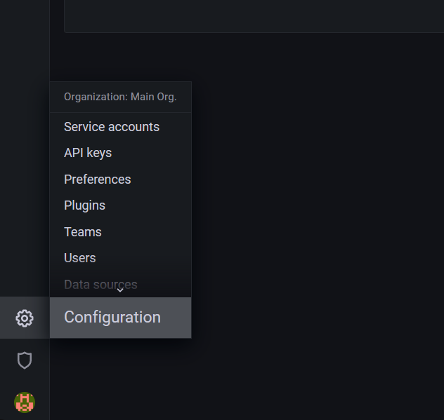

* In the following screen open the plugin tab.  
  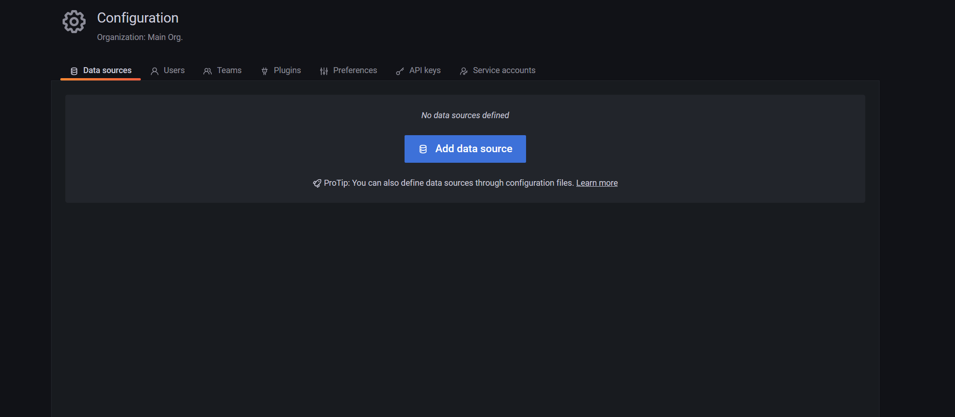
* And within the plugin tab, search for the following : MYSQL

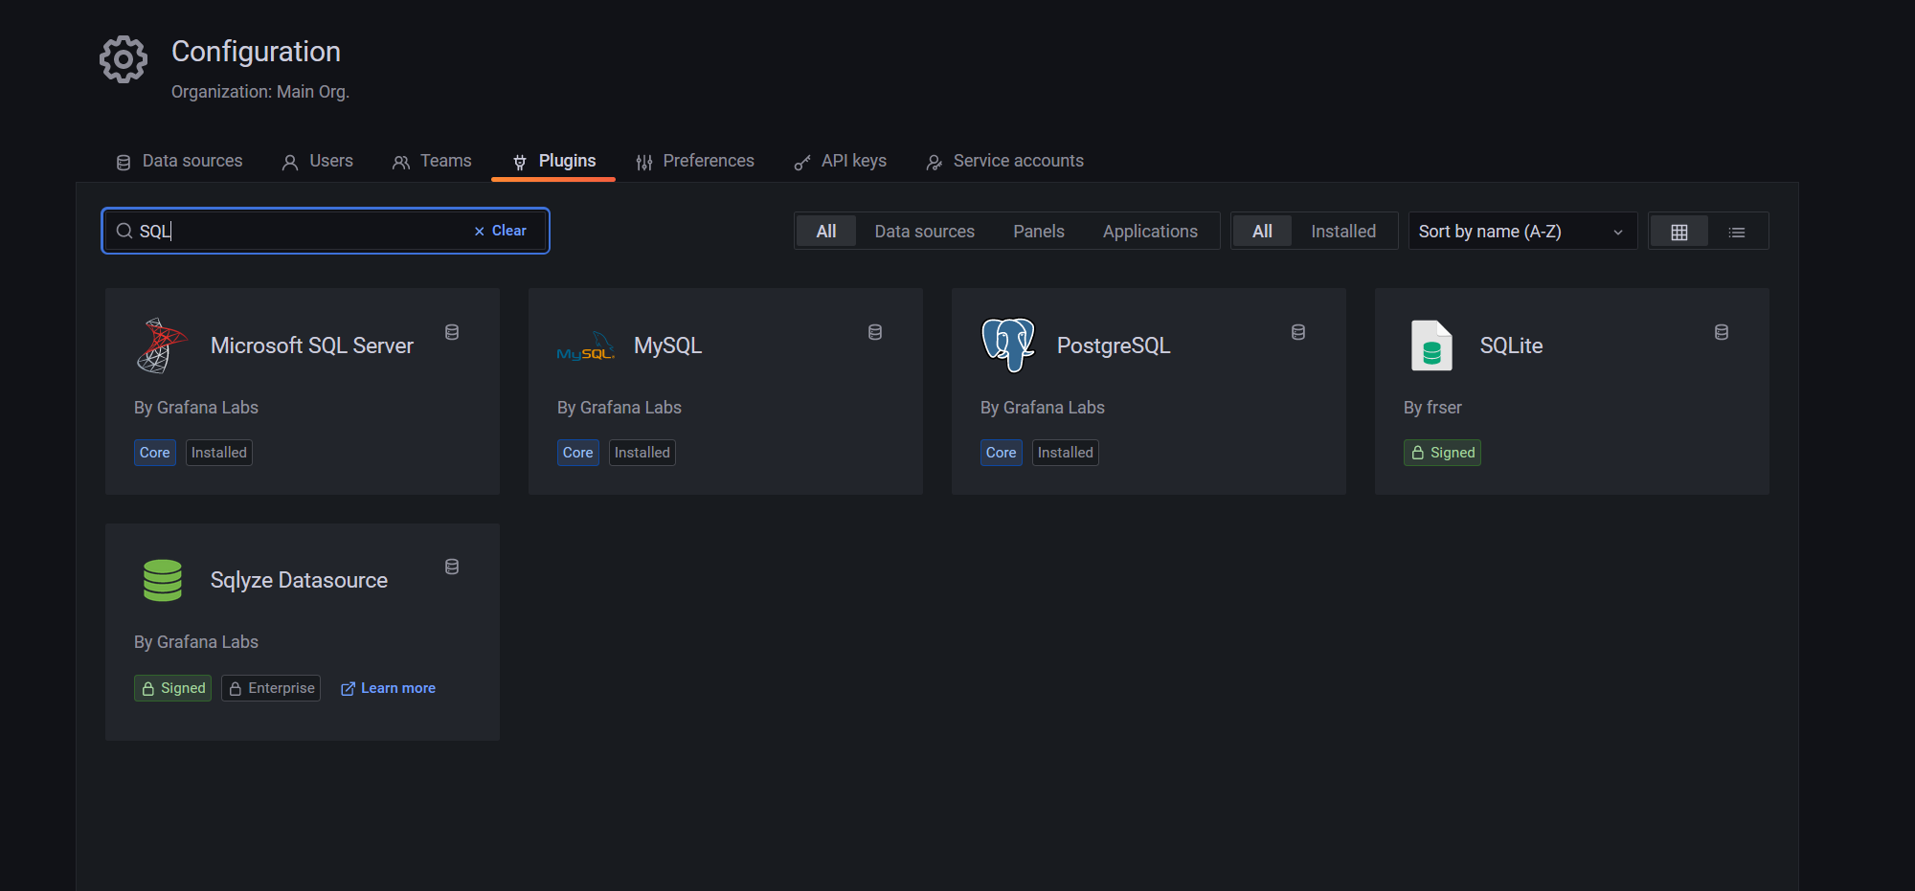  
When you see the MySQL plugin. Click on it to open the plugin screen, and click on create ‘MySQLDatasource’

Within the screen that opens next, fill in all the credentials needed to make a connection to the ASOC_Grafana . When finished, press ‘Save & test’. The connection between MySQL and Grafana is established.

# Install the Node JS runtime of version 16.16.0

* Install the Node JS by accessing the URL: <https://nodejs.org/ja/blog/release/v16.16.0>
* Download the exe from the above link

## Configure the .env file

* Open the command prompt from the home directory where the Nodes JS is installed and run the command **“npm install”.** This would install the required libraries.

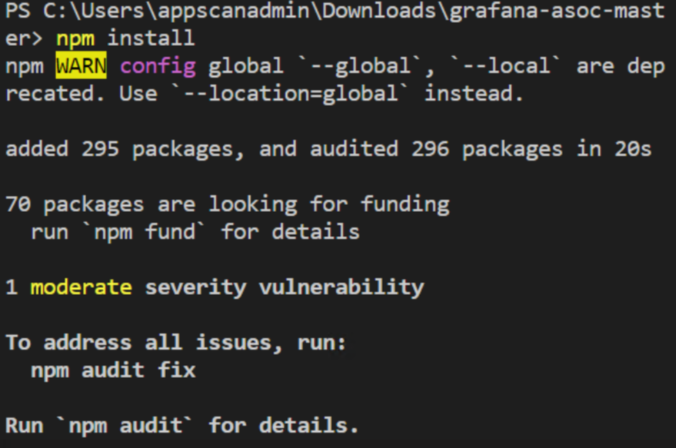

* In the “Grafana” folder, edit the file “.env” (rename .env.temp to .env) from home directory to make changes to the below properties:

ASOC_URL = *<URL of the AppScan on Cloud>*

KEYID = "<keyid of AppScan on Cloud>"

KEYSECREAT = "<keySecret of AppScan on Cloud>"

SECURE_PORT = <Port Gateway application listens to>

APP_LOG = <Path name of the log file>

NUMBER_OF_BACKUPS = <Number of backups>

SERVER= <MySQL Server name>

DRIVER= <MySQL driver name>

DATABASE= <Grafana DB name>

DB_HOST= localhost

DB_USER= <MySQL database username>

DB_PASSWORD= <MySQL database password>

DB_DATABASE= <Grafana DB name>

NODE_TLS_REJECT_UNAUTHORIZED=1

* In Nodejs, run **‘npm start’** to start the server.
* The Nodejs application would fetch the data from ASoC and store in the database Asoc_Grafana

# Setup the Dashboard

Now that we have Grafana installed and the DB connection setup, we can now prepare to import the dashboard view into Grafana.

* Open Grafana through the web browser and login

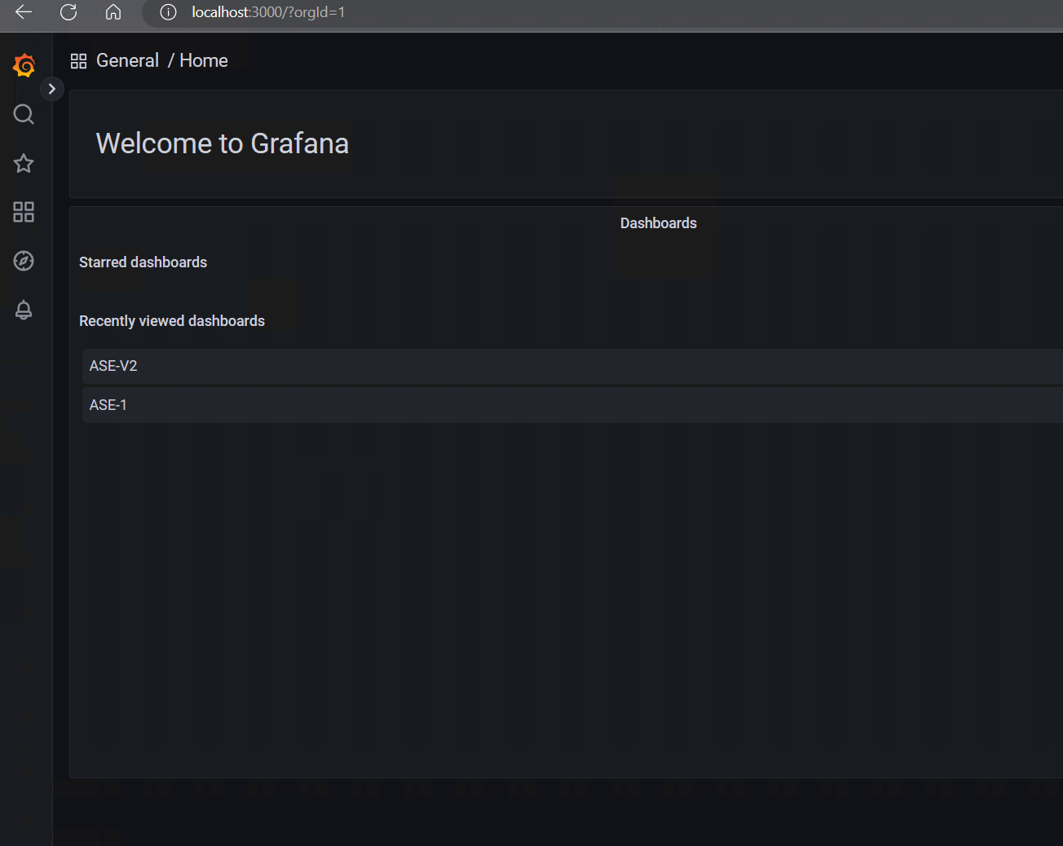

* In the main screen, go to the left menu and click on ‘Dashboards’

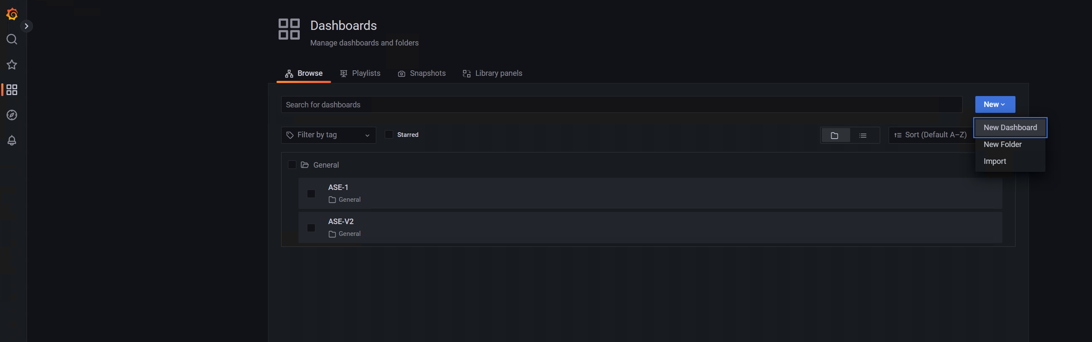

* In the tab that opens, click on ‘new’ and select ‘import’

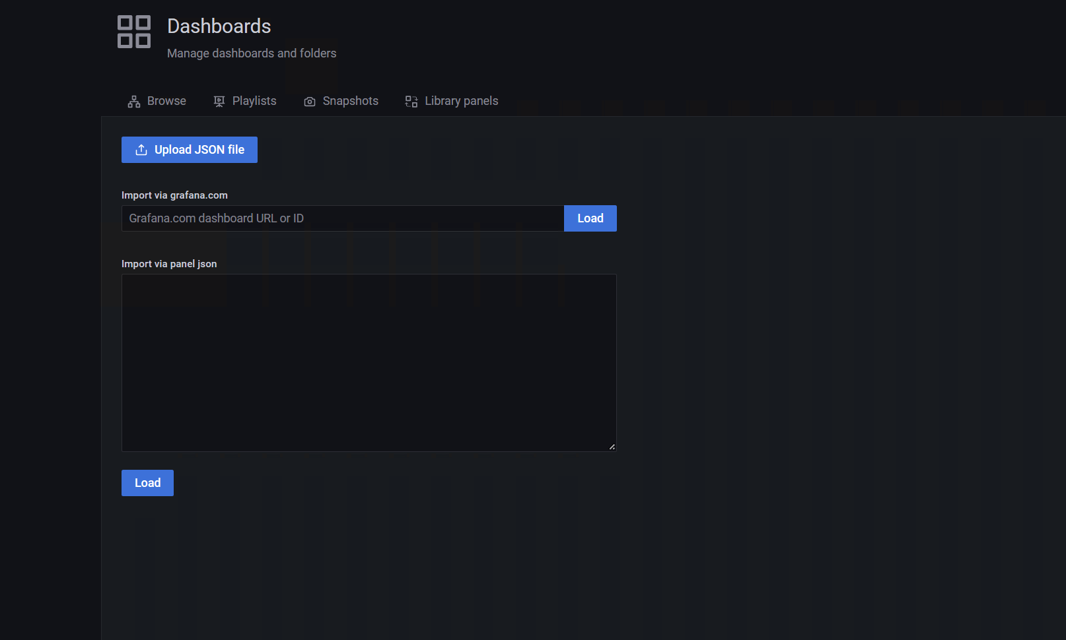

* Go ahead and press ‘Upload JSON file’ and locate the provided JSON file. (Provided in the same folder as the installation guide)

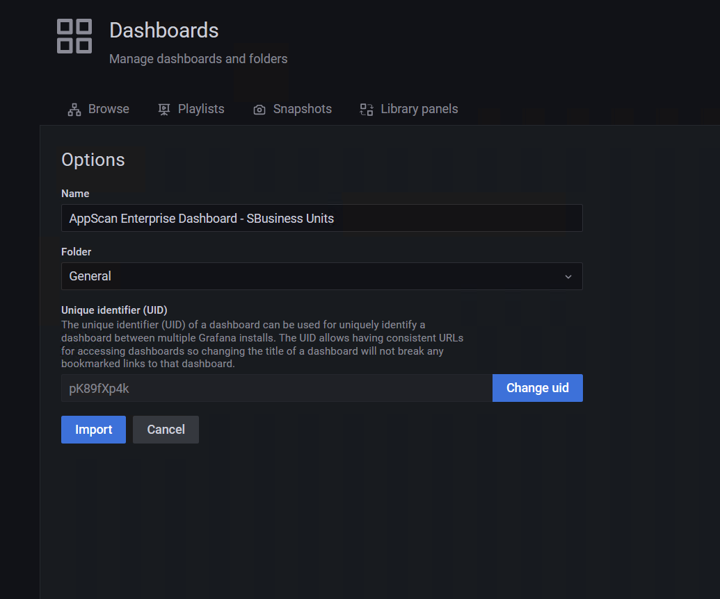

* Give the new dashboard a name. No need to change the Folder or the unique identifier (uid) and then go ahead now and press ‘Import’. As soon as it is ready, the new dashboard will open.

Before we can use the dashboard, we need to setup some dashboard settings.  
When in the dashboard page go and open settings.

* In the following page, select the Variables menu and click on ‘Application name’  
  A screenshot of a computer

  Description automatically generated
* Here we need to make sure that we have selected the correct DataSource. If not, go ahead and change it to the previously created DataSource.  
  A screenshot of a computer

  Description automatically generated
* Next, we need to ‘Run query’ first, then select ‘Apply’  
  A screenshot of a computer

  Description automatically generated
* Now go ahead and save the dashboard.  
  A screenshot of a computer

  Description automatically generated

* Now go back to the dashboard view. The data would appear in the dashboard as below:

Now you are all set.

# Grafana dashboards – Graphs

The Grafana dashboard consists of below graphs:

1. License Consumption
2. AppScan trend
3. Applications Onboarded
4. Fixed Rate Trend
5. Code Quality
6. Flaw Density (SAST)
7. Flaw Density (DAST)
8. Average Days to Resolve
9. Number Of Vulnerabilities
10. Vulnerability (cumulative)
11. Number of Scans(monthly)

Attached the PPT with the description of each graph.



# Testing

The below attached testcases were used to test the entire application.

